6COSC023W
Computer Science Final Project

Project Proposal and Requirements Specification (PPRS)
Handout

Title
A precise AI model to accurately diagnose health related issues

Student: Stirling Idle(w19796028)

Supervisor: Olivier Moullard

Degree: BSc/BEng (Hons) Computer Science

School of Computer Science & Engineering
College of Design, Creative and Digital Industries
University of Westminster

05/11/2025

All sections in orange (like this one) must be replaced by your own content or just deleted and removed before submitting this document.

On the Title page (first page), please include the “Project Title” (it can be changed later), your full name, your supervisor’s full name and the submission date.

Declaration

This document has been prepared based on my own work. Where other published and unpublished source materials have been used, these have been acknowledged in references.

Student Name: Stirling James Idle
Date of Submission: Submission date

This is an important section!
Add your name and the date of submission.

Definition of the Problem
- Problem Description: Many medical professionals including Doctors & Nurses come face to face with many challenges due to ever evolving responsibilities and many interruptions within the Health Care sector as it is a constantly evolving and changing sector. In addition, as disease can develop over time and the actual dynamic of the patient changes over time, which can make the overall diagnosis of disease more challenging and time consuming which will have negative consequences for the future. AI can process information exceptionally faster than the human mind can, and as a result, the AI is able to help assist healthcare professionals with determining the optimal treatment for their patients. However, as an AI mind is inspired to that of the human mind, there can never be 100% accuracy as 100% accuracy would be biased and would leave room for failure. However, a recent blog in 2024 offered by the BBC regarding the use of generative AI (which is a type of artificial intelligence which is used to generate specific content including; text, images) which will be transformative to the patient’s outcome (said by Sir John Bell) (https://www.bbc.co.uk/news/articles/c6233x9k4dlo) He also said that when allowing AI to access the data of patients should be secure and safe for the patient, furthermore, if the data is accurately shared with the AI, the AI model could make a valid judgement on what is perhaps wrong with the patient and could help prescribe some sort of medication.
- Significance: The AI model that I will develop will accurately, or at least to a degree of accuracy, help medical professionals (Doctors & Nurses) identify disease and prescribe the appropriate medication. The AI model will utilise machine learning algorithms such as Linear Regression to help predict how much medication the patient will need as well as what would happen if they don’t take their medication and give them an estimated time frame. Furthermore, I will also use supervised learning where I teach the AI model to know what things are right and what is wrong, like a child learning something for the first time. Also, lastly, my AI Model will use Deep Learning which contains a whole list of algorithms which all together learn using large amounts of a collection or processes, a bit like unsupervised learning. My AI model will improve on both accuracy and performance over the many other AI models already in use in health care, such as; diagnostic (Which is my primary objective to address), imaging & detection models. The ultimate goal of my AI model is to improve on the accuracy of current AI Models in use in the Health Care & the sector to which they are applied.

Aims, Objectives, and Scope
- Aim: The primary goal of this project is to develop an accurate AI Model which utilises machine learning algorithms such as Linear Regression & supervised Learning, as well as generative AI to help generate a human like response for the patient and health care professional and to generate an image of any implications to the patient. The project aims to improve on the accurate representation of information represented to the patient by using machine learning techniques to improve on the search algorithms which are used to predict the most likely outcome by looking through every possible sequence and choosing which one would most likely happen, using alpha-beta pruning to eliminate branches of the tree which won’t affect the final decision.
- Objectives:

- Develop a user-friendly login page using Apple’s Swift programming language, with appropriate font, colour and spacing to make the information be displayed as clear as possible. Furthermore, I will also aim to develop a sign in option, so that if this is the user’s first time using this application, they can create an account using their private email address, username & password.

- The application will possess the following features:

    - use of Apple’s facial recognition technology (Utilising the True Depth camera which is a type of hardware built into Apple’s software, it is a flood sensor array which is stored on many Apple devices and uses a combination of dot projector, flood illuminator & infrared camera which are all together used to create a detailed “map” of the user’s face.).

    - Security Techniques such as Authorization & Authentication (password AutoFill, Shared Web Credentials, Authorization Services, Authorization Plug-ins, Sessions & One-time codes), in addition, Secure data methods such as Keychain services (Which are used to securely store small amounts of Data on the User’s behalf) & Preventing Insecure Network Connections, which enforce secure network links within the app by relying on App Transport Security.
(Reference: https://developer.apple.com/documentation/security)

    - As this application’s main aim is to help assist in the diagnosis of various diseases, the app will include a chatbot (built into the app) which utilises the use of GPT(Generative pre-trained transformer) which is a type of LLM (Large Language Model) which “utilises deep learning to produce human like text”. It will produce human like text to make the interaction between user and computer appear more authentic & professional. It will be capable of this due to it being a transformer which “allows it to analyse entire sentences simultaneously, rather than sequentially, grasping relationships between words regardless of their distance”.
(Reference: https://cloud.google.com/discover/what-is-gpt)

- I will ensure that the application has the will:

  - Act in accordance with British Ethical laws & standards such as: The Data Protection Act 1998 & 2018, which is a legislation which was passed by the British Parliament which governs the protection of personal data in the UK), The Computer Misuse Act 1990, which describes and criminalises a number of offences involving the use of a computer, an example being unauthorised access to computer systems & The Copyright, Designs and patents Act 1988, which gives the creator of the application or software the control over the way it is used.
(Reference: https://www.bbc.co.uk/bitesize/guides/zhx26yc/revision/3)

  - One of the further goals of this application is to be friendly and inclusive to everyone not just one individual. As discussed in the previous section on features, the use of inclusive font, colours & spacing will help accommodate those which might suffer from dyslexia or any other text related disability, the colour accommodation is especially useful to those whom might require the use of a digital overlay to help them read text from the screen.

  - I will also ensure that the applications GPT model securely and to a degree of accuracy (using the Machine Learning technique Linear Regression for prediction purposes) processes the user’s data and information to predict the disease based on the symptoms which the user describes to the AI Model. The AI Model will also reference chat history so that say if the app crashes or something else out of your hands happen, the AI Model will remember what you said, but in the real world it will not remember everything as this is impractical.

Specific Outcomes:
- Secure use of authorization & Authority techniques to protect the user’s information from any external or malicious attacker.

- Functional, user friendly & inclusive app which is easy to navigate, taking the user from a sign in page (or create account page) to the room where the user can tell the AI Model their symptoms and the AI Model will response with an appropriate response, then summarises the appropriate medication to be taken, and where to safely acquire them.

- An important implementation/outcome is for the AI model to know any history about the disease (how severe/dangerous it is), it will utilise supervised learning to accomplish this.

- The application must abide by the UK Ethical Laws and standards governed by Parliament for the use of data, security and Malicious attacks (Data protection, The Computer Misuse Act 1990, The Copyright, Designs and patents Act 1988).

- Scope:
  - Inclusions: The project will include functionalities such as:
  - Facial Recognition A secure method for accessing sensitive information of the user.
  - AI Model An accurate AI model which makes use of GPT to generate a human like response and give predictions-based information provided by the user.
  - Programming Language The application will be largely built making use out of the Swift programming language as this is the main programming language used to build IOS applications (other than Objective - C). Apple also provides an IDE called X-Code which provides a virtual simulator for testing and production services.
  - Keyboard for text based input A keyboard will be implemented so that the user can input their information and the AI model can analyse the information.

  - Exclusions: The project will not include:
  - Speech via input the user will not be able to implement information via word of mouth.
  - Soley built for disease diagnosis It won’t have any information on anything other than diseases & medication.
  - No external website There will be no external website for the application, it will be an app built in X-Code and published into the App store for public use once completed.

Background Review
- Key Findings (Literature / Systems):
Summary of-key Literature findings:

Apple’s-developer documentation provides a plethora of information which describes that when users select an item from the Quick-Type bar, the system will ask them to authenticate using facial recognition (Face ID) or Touch ID, two types of biometric authentication offered by Apple. The app becomes inactive when Face ID or Touch ID appears as this will hide any information which is not meant for anyone else other than the user, which triggers the app’s delegate’s applicationWillresignActive( :) & applicationDidBecomeActive( :). “Then once the suer authenticates successfully, the system changes the first responder to the views to be autocompleted – even if the app prevents changes to the first responder normally. The system then fills in all the relevant views“. Furthermore, Apple’s documentation on Password AutoFill & Security explains that “For IOS apps, the system always sends a textDidChangeNotification notification when a view has been modified. It also calls one of the delegate methods of the view – but the exact method depends on the view’s type”.  There are a plethora ethical laws which have been passed by the British Parliament to help make data protection secure between clients. The first one being The Data Protection Act, which was passed by the British Parliament in 2018, which states that “Everyone responsible for using personal data has to follow strict rules called ‘data protection principles’ unless an exemption applied” which is extremely important. It also specifies that anyone responsible for using personal data must make sure the information:  - Used fairly, lawfully and transparently.  - Used for specified, explicit purposes.  - Used in a way that is adequate, relevant and limited to only what is necessary.  - Accurate and, where necessary, kept to date  - Kept for no longer then necessary.  There is also a section on what exactly your rights are, which range from  - Being informed about how your data is being used.  - Access personal data.  - Have incorrect data updated when needed.  - Having data erased.  - Stop or restrict the processing of your data.  - Object to how your data is processed in certain circumstances.  (Reference: https://www.gov.uk/data-protection)  There are many gaps within security including the 3 biggest gaps in Cybersecurity which are:  - Weak passwords and lack of Multi-Factor Authentication.  - Outdated Software & Unpatched Systems  - Lack of Employee Training & Awareness. | In terms of security & Authentication, Apple uses a password-Autofill method which simplifies the login and account creation tasks for IOS apps and webpages. This is accomplished “with just a few taps, your users can create and save new passwords or log in to an existing account ”. The user doesn’t even need to know there password for this either. Also on Apple’s developer website, it states that users are more likely to complete your app’s onboarding process and start using your app more quickly, also, by increasing the overall security of the app.  The Computer Misuse Act 1990:  The Computer Misuse act was passed by the British Parliament in 1990 which is the legislation that “criminalises unauthorised access to computer systems and data, and the damaging or destroying or these”. The purpose of this law is to protecting the integrity and security of computer systems and data through criminalising access to them which has not been authorised by the owner of the system or data. The UK Government website which explains in detail of the different ways in dealing with criminals is:  - Take Down This is one of the simpler ways of dealing with the criminal use of domain names is to require the registrar responsible for the creation of the domain name to remove it from the list of registered names.  - Takeover by law Enforcement This is where “Domain names are used by criminals to link their command-and-control platforms with infected computer systems to control them, where in some cases, industry takedowns can be insufficient to stop these background processes from continuing to operate. “  Weak passwords and lack of Multi-Factor Authentication:  This is one of the simplest ways a cybercriminal can break into your system. This is due to many businesses relying on easy guessing passwords such as ‘123456…’ or even just ‘password’, as well as, reusing passwords which are shared across multiple accounts or websites/apps, this can lead to a domino effect of compromised data. However, this can be fixed by:  - Strong passwords (Long / complex and unique for every account).  - Multi-Factor Authentication – Is still a simple but very powerful extra layer of security, like a one-time code sent to your phone. | Furthermore, password AutoFill works within the app in 3 key events:  - App first installation on a device.  - User selects a text input view in your app.  - User taps on AutoFill item from the Quick Type bar.  So, when the app first installs on a device, the system (IOS) tries to associate said app with all the domains listed int eh app’s Associates Domains Entitlement:  - First, the system takes each domain from the Associated Domains Entitlement.  - An attempt is made to download the Apple App Site Association file for that domain.  - Lastly, if all of the successive steps complete successfully, then the system associates the app with that domain, and enables password AutoFill for that domain’s credentials.  The copyright act 1988:  The copyright Act of 1988 states that the owner of the created software or product has complete ownership of their product and how it is released and how others use it. All of this is explained in the Copyright, Designs and Patents Act 1988 complete documentation chapter 48 from 15th November 1988: “An Act to restate the law of copyright, with amendments; to make fresh provision as to the rights of performers and others in performances; to confer a design right in original designs; to amend the Registered Designs Act 1949; to make provision with respect to patent agents and trade mark agents; to confer patents and designs jurisdiction on certain county courts; to amend the law of patents; to make provision with respect to devices designed to circumvent copy-protection of works in electronic form; to make fresh provision penalising the fraudulent reception of transmissions; to make the fraudulent application or use of a trade mark an offence; to make provision for the benefit of the Hospital for Sick Children, Great Ormond Street, London; to enable financial assistance to be given to certain international bodies; and for connected purposes”  Outdated Software & Unpatched Software:  A very important thing is to keep your system updated, this is because Cybercriminals actively look for outdated software because its full of known vulnerabilities that they can exploit, a prime example would be the last version of Windows (Windows 10) which when it approached the end of its life isn’t still supported, so if you were to still be using it, you would be at more greater of a risk then if your were to update to Windows 11.  However, there are ways that you can help prevent malicious attacks, such as:  - Keep everything updated, including operating systems to apps and security software.  - Automate updates where possible to avoid delays.  - This also includes business devices, laptops, phones, tables, all of which will still need to have regular security updates. | In addition to the topic of password AutoFill, when the user selects a supported input view or HTML input element, password AutoFill displays the Quick-Type bar above the keyboard and populates it with relevant options for the given field. However, in contrast if the user has not selected an input field, the system will then use heuristics (Heuristics will guide search using domain specific knowledge) to identify the views type and determine if its’s supported, also, like the vast majority of apps IOS, Windows & Linux, password AutoFill supports input views and HTML input elements for; user names, existing passwords, new passwords & security codes. However, the Quick-Type bar only appears if the user has at least one password saves on an IOS device and the keychain AutoFill setting is enabled, also, when using an Apple Application, you will often see a key symbol, when this is pressed it displays a long list of passwords currently saved on that system, whereas the Quick-Type bar includes any credentials for your associated domains. A practical example of this would be:  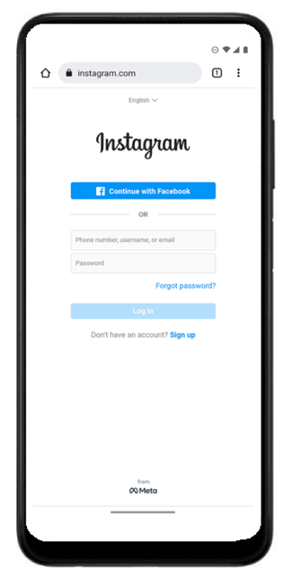  What is GPT & How does it work?  GPT stands for Generative pre-trained Transformer and is a type of LLM (Large Language Model) which utilises Deep Learning to produce human like text. Is also uses Neural Networks, which are trained on large amounts of datasets which contain text & code which enables them to understand and generate coherent and contextually relevant responses.  “GPT models work as complex network of artificial neurons which are organised into layers to process information deeply, much like the human brain”, also, going back to the notion of a Transformer, a transformer is a type of neural network design which was invented by Google researchers back in 2017, the transformer its self is able to scan and analyse entire sentences simultaneously , rather than sequentially, grasping relationships between words regardless of their distance. Furthermore, this ability of self-attention is a mechanism which lets the model weigh the importance of each word in relation to all others, mimicking how humans focus on different parts of a sentence for context.  Training a GPT model involves a tedious process of “feeding” large amounts of data (books, articles, code, online conversations). This is a prime example of supervised learning as this is a repeated exposure and process called ”Backpropagation” where it learns from prediction errors which means t becomes quickly adept at understanding and generating human-quality text.  There are many ways of training and developing a LLM, including:  - Vertex AI  - Vertex AI Studio  - Vertex AI Model Garden  - TPUs  - Compute Engine  - Natural Language AI  Lack of Employee Training and Awareness:  Some of the top causes of Cybercrime are, phishing emails, social engineering scams & accidental data leaks and without the proper training or knowledge on how to spot and be aware of these would lead to putting your information or your business at risk or data compromise.  There are several ways of being competent to spot these malicious attacks such as:  - Regular cybersecurity awareness training to keep you alert to threats.  - Simulated Phishing exercises to test and improve response rates.  - Clear policies on reporting suspicious activity.  However, cybersecurity in general isn’t one and Done, it is an ongoing process, in order to stay safe, you must:  - Identify vulnerabilities, security gaps, and potential threats.  - Provide expert insights tailored to you or your business.  - Give you actionable recommendations from experienced security engineers.
Problems with Apple’s Facial recognition:  The BBC has an entire article dedicated to a scandal about a problem called “Apple explains Face ID on-stage failure”, this article is about why Apple’s new facial recognition feature failed to unlock a handset at an on-stage demo at the iPhone X’s launch on 14th ,September 2017, Apple explained that the glitch was due to staff members moving the device ahead of its unveil. Furthermore, a quote from Yahoo’s David Pogue stating that “People were handling the device for [the] stage demo ahead of time and didn't realise Face ID was trying to authenticate their face”. Furthermore, at its launch, the company had earlier described Face ID as being “effortless” to use and more accurate that its fingerprint-based Touch ID system, however, as the newer generations of iPhone are being released, they lack the old authentication system because it lacks a fingerprint sensor.  This BBC Article also says that there are still large amounts of questions needing answers undermining the Face IDs ability to protect the User’s privacy & security and whether the technology will perform equally well on different groups of people.  (Reference: https://www.bbc.co.uk/news/technology-41266216) | There are many concerns about the security concerns on Facial Recognition, all of which are explained in Apple’s About Face ID advanced Technology documentation page, such as:  - Face ID automatically adapts to changes in your appearance, such as wearing makeup, or growing facial hair., so theoretically there would always be a probability that your data could be at risk but its what stands between your data and the attacker.  Under the section called Security safeguards, it explains that there is a probability that a random person in the population could look at your iPhone or iPad and unlock it has the probability of less than 1 in 1, 000,000 with a single enrolled appearance, whether you are wearing a mask. It also explains that Face ID gives you a maximum of 5 unsuccessful match attempts before a passcode is required. Also, the probability is generally higher if using Face ID with a mask (examples include twins or siblings that look like the user, and children under the age of 13, because their distinct facial features may not be fully developed yet).

- Comparison with Similar Software Applications/Products

ChatGPT
Strengths |  | Weaknesses
ChatGPT is a free open-source AI model for use by the general public |  | ChatGPT pulls information from static, rather than live data.
ChatGPT is able to quickly analyse information and generate an appropriate response. |  | There is no content available before 2021.
ChatGPT has an extremely large database, which means it is able to make broad connections between information. |  | ChatGPT is unable to predict future events.
ChatGPT is able to summarise information which in turn saves time. |  | Sometimes will produce inaccurate responses & information
ChatGPT is able to generate new content by analysing existing resources |  | ChatGPT’s responses may appear biased and one sided.
ChatGPT’s responses are well written and easy to read. | ChatGPT’s responses contain no references of the information provided.

DeepSeek

Strengths | Weaknesses
Enhanced Data Analysis DeepSeek is able to process a vast amount of data quickly and efficiently, including analysing patterns in finance & Healthcare and many other sectors. | Potential Job Displacement DeepSeek may make many employees become redundant as it has automation of many tedious tasks, which will result in workforce disruption.
Improved Efficiency and Automation DeepSeek reduces the need for human error by automating tasks in which a human may find repetitive and enhances productivity. | Increased Dependency on Technology If you reply heavily on something else to do your tasks for you, you aren’t really improving your skills, this could result in skill erosion and could result in system failures because if you don’t know what to input to the AI model, then the AI model will produce the wrong results.
Real-time decision making DeepSeek offers almost seeming less insights to support high stake decisions in various fields including, finance, emergency services & logistics | Ethical and Bias Concerns DeepSeek may inherit data bias which will lead to discriminatory outcomes to many demographic groups or industries, as well as opacity in decision-making.
Greater Accuracy in Tasks DeepSeek excels in producing information for areas which rely on precision-critical information. | Lack of transparency in decision making AI models quite often use “Black Box”, which is where the implementation (or the Algorithm) used for decision making is hidden from the user, this could lead to trust issues between user and AI.
Scalability across Industries DeepSeek is a very adaptable AI model and is used widely across sectors such as; healthcare, education & manufacturing, it also possesses the ability to scale itself where needed. | High Initial Implementation Costs DeepSeek requires a very high upfront investment in hardware, software and that of a skilled operator (person).

Google Gemini
Strengths | Weaknesses
As Google Gemini was developed by google, it has the capability to integrate with Google applications and the Google ecosystem. | As with AI and humans, Google Gemini has the potential for hallucinations & inaccurate response outputs.
Goole Gemini has multimodal understanding, including that of; Text, image, audio & video. | As with many open-source AI Models, DeepSeek requires a paid subscription for the use of many advanced features.
Google Gemini has Real-Time information access. | Google Gemini has privacy and data security concerns when uploading sensitive Data.
Google Gemini can help developers and programmers as it has enhanced coding assistance with configurable thinking budgets. | Google Gemini can have latency and performative issues when dealing under high pressure environments.
Google Gemini has broad language support and translation features. | As Google Gemini falls under the Google ecosystem, it has a high dependence on the internet and the Google Cloud infrastructure.

Differentiation
- The AI model that I will develop will build on the strengths on these 3 AI models (ChatGPT, DeepSeek & Google Gemini), as well as addressing the weaknesses described in all 3. My AI model will not have any paid features, it will summarise information in a way that the user can easily see and understand, it will offer support features for the user (as my AI model will give guidance on medication and use predictions to help the user). As my AI model will use the GPT model (Generative pre-trained transformer), it will be able to generate text & images of what the could happen to the patient if they do not take their medication and summarise the implications of not doing so. It will also use the strength discussed on DeepSeek’s scalability, it will possess a large amount of information on medication & disease datasets, this is also in relation to ChatGPT’s use of an extremely large database for broad connections of information and make valid judgements for the user to use. Furthermore, as my AI model will help guide users on what to do if they don’t feel well, the AI model will rely heavily on having a greater accuracy of tasks which is critical in

Tools (Hardware/Software)
- Hardware:
- iPhone iOS, macOS, watchOS

- Software:
- Xcode Xcode is the standard development system used to develop IOS applications for Apple devices such as; iPhone, Mac, Apple Watch and Apple TV. This is because Xcode contains a large virtual environment which contains; code implementation, source control, powerful debugger and a powerful virtual device simulator which can help in the process of testing the application. Furthermore, in the context of developing an AI model, Xcode allows the developer to train a custom machine learning model with the help of create ML (supervised learning, unsupervised learning & linear regression). Furthermore, Xcode provides the developer with the option to add swiftUI previews, which enable the developer to view their UI as they build their application.

- Microsoft’s AI Builder Microsoft’s AI builder is used primarily for the use of powerful apps and 365 apps, however, with the use of Restful APIs, which I will use to integrate my IOS applications and the AI model via sending requests to and from the cloud this will be possible. In addition, I will build the AI Model by using data types such as text & images, as these are the two most important ones. The AI Builder also contains something called a “Custom build” which allows the developer to build, train and publish a model for use. In addition, it also contains a “prebuilt” build type which comes ready to use to the developer.

- AWS I will use the AWS (Amazon web services) for the integration of my AI model and the IOS application, as AWS contains many useful services such as: Robust Connectors this contains an unlimited connectivity integration such as APIs, API Management which enables the developer to create, design and manage a secure API and then publish said API & an Integration section This section is based upon the purpose of making a faster and more easier way of leveraging a large library or pre-built application connectors and integration recipes which will make the process of integration appear much faster.

Use Cases and Diagrams

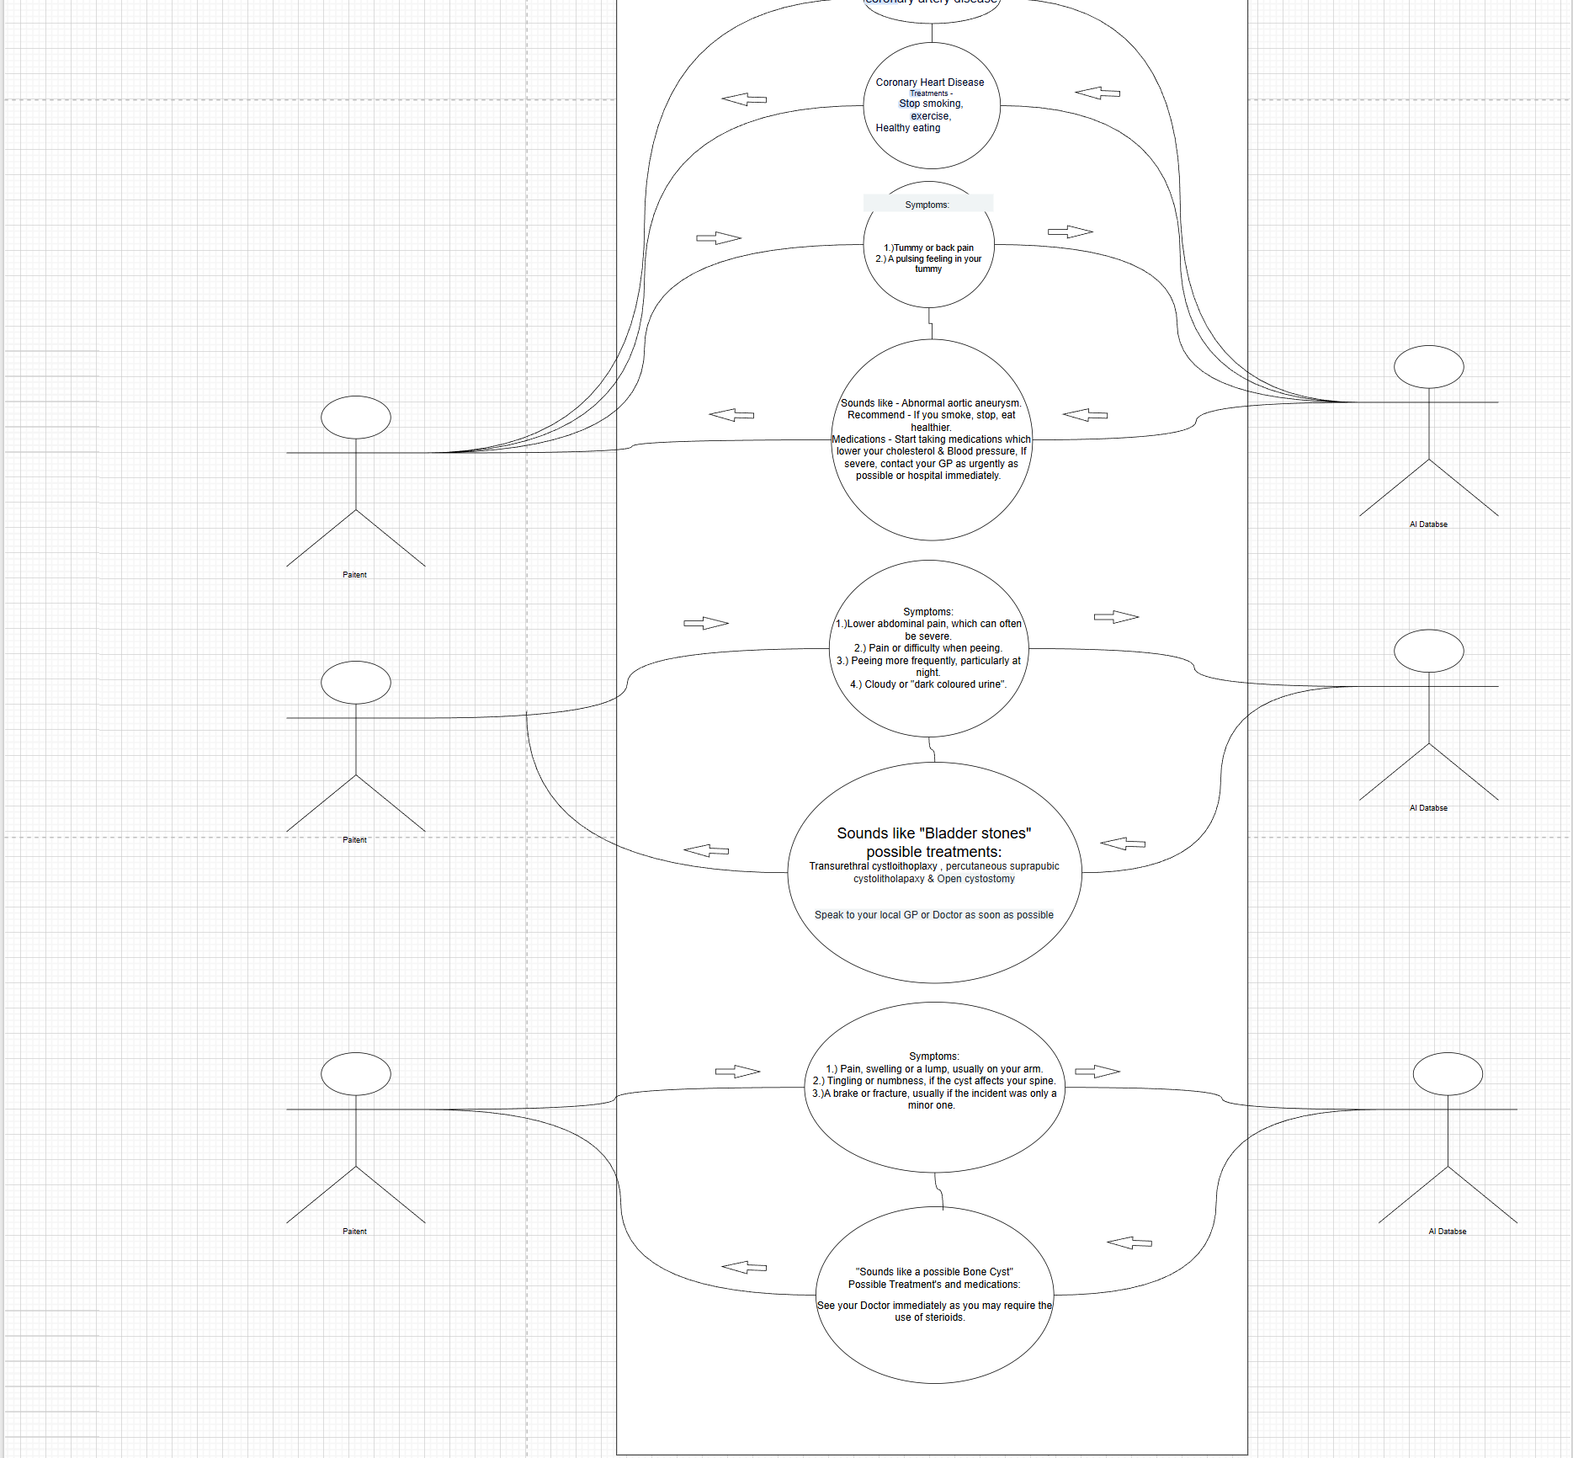
- The above use case diagrams show a process where the user will manually input their symptoms and then the AI analyse the information and compare the user’s symptoms with its database and then draw back a valid response containing the appropriate action which the user should follow, including and appropriate medication and if they should immediately contact their healthcare professional depending on the severity of their illness. The use case only shows 4 diagrams displaying 4 disease and their appropriate treatments, however, in the real world, there are thousands of diseases in which this AI model will have to adapt to and provide accurate treatment based upon the symptoms of the user. The AI model will use information across websites on the internet, especially that of the NHS as they contain a thorough list of diseases and their treatments as well as their possible symptoms. So, in conclusion, the above use case diagram describes an efficient process of a basic input and output structure, where the user enters their symptoms and the AI model attempts to make an accurate judgement on what to output to the user based upon the information provided.

Requirements Elicitation
- Approach:
In order to gather their appropriate information such as gathering data on diseases and their treatment & medication, I will primarily use the NHS’s documentation on diseases as it contains a list of diseases and illnesses complete from A – Z, then, I will train the AI model on this data so that it is able to use techniques such as Search algorithms such as; Tree Search which is a search algorithm which scans all possible problems and then returns a sequence of actions based upon current context, graph search which is a modified Search which is the process of visiting every vertex or problem and then storing each visited node in a closed set to help avoid repetitive work and loops, as well as Depth first Search which is where the deepest nodes are expanded first, so, in the context of scanning information of diseases, the context of the disease (History of the disease, treatments, symptoms, how the treatments has effected prior individuals who have suffered from the disease in the past). I will also be using the concept of heuristics which will actually help in the process of searching through all possible problems and returning an action based about current pretexts, in this context, a heuristic will help guide search using domain specific knowledge, which means it will save time by finding alternative routes which shorten the amount of time it takes for the search algorithm to find an appropriate action. In addition, as this is largely a process of using search algorithms to determine an accurate outcome, the concept of Big O Notation could be used which measures the upper bound growth of an algorithm which describes how input scales with runtime, so, if the user enters a large amount of data, Big O notation could be mixed in with Tree Search to help accommodate for the large amount of memory required to execute the task.

Techniques: Xcode, Search Algorithms such as; Tree Search, Modified Search, DPS (Depth -First Search), Big O Notation, NHS documentation regarding diseases and their treatment from A – Z, Object Orientated programming (In both Python and Swift), Waterfall software Development approach, which describes how a project should be implemented from its initial Design through to its release where each subsequent step should be completed before moving onto the next.
- Requirement Specification
Functional Requirements
- As described in the projects Aims & Objectives, the project’s aim is to develop an accurate AI model which can be used by healthcare professionals including Doctors, Nurses & GPs to prescribe medication and treat diseases. The user (or patient) will enter their symptoms by manually inputting them via a digital keyboard on their device giving the AI prompts to analyse and return an appropriate response which will first include a human response being empathetic towards the user through tone, then, a list of treatments and medications appropriate to the disease and a message at the end of the text depending on the severity of the disease stating whether or not they should visit their Doctor immediately. Then at the end of the interaction, the AI model will summarize the information in a visible format to the user can understand it easily in the form of a graph or similar.

Non-Functional Requirements:
- However, due to the time scope of this project it will not be feasible to implement to a level like that of ChatGPT, DeepSeek & Google Gemini, but to make something that works efficiently and works as intended to. This AI model will be able to do all of the above but will not include, speech recognition, website production, code generation or anything other than generating an image and text as it uses gen AI to do so, but it will only be able to generate text & images based upon information.

Time Schedule
- Gantt Chart Overview:
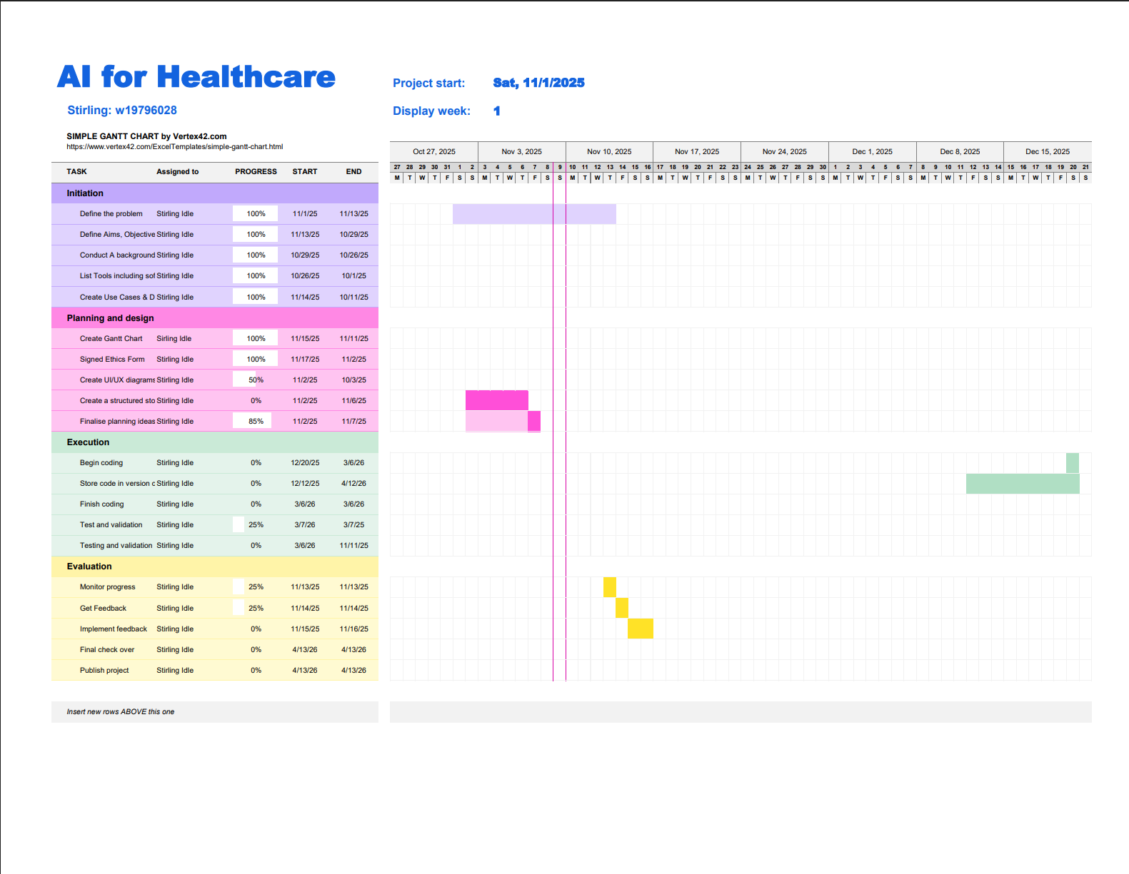

References / Bibliography
  - BBC (7 August 2024). AI in healthcare: what are the risks for the NHS?. Katharine Da Costa)
  - Apple. Secure the data your app manages, and control access to your app
  - Goole Cloud. What is GPT
  - BBC. Ethical, legal and environmental impacts of digital technology, BBC Bitesize
  - BBC (14 September 2017).Apple explains Face ID on-stage failure.

Ethics Form
- The downloaded Ethics Application must be included in this document. The Application must be signed by you and your supervisor BEFORE being included in your submission.

